**LAB REPORT**

***Submitted by***

**H.MADAR HUSSAIN KHAN**

**RA2011030010109**

***Under the Guidance of***

**Ms .P. Mahalakshmi**

**Assistant Professor, Computing Technologies**

***In partial satisfaction of the requirements for the degree of***

## **BACHELOR OF TECHNOLOGY**

**in**

**COMPUTER SCIENCE ENGINEERING**

**with specialization in Computer Science cyber Security**

**SCHOOL OF COMPUTING**

# **COLLEGE OF ENGINEERING AND TECHNOLOGY**

**SRM INSTITUTE OF SCIENCE AND TECHNOLOGY**

**KATTANKULATHUR - 603203**

**JUNE 2022**

SRM INSTITUTION OF SCIENCE AND TECHNOLOGY

KATTANKULATHUR-603203

**BONAFIDE CERTIFICATE**

Certified that this lab report titled **“Food delivery system”** is the bonafide work done by H.Madar Hussain khan (RA2011030010109) who carried out the lab exercises under my supervision. Certified further, that to the best of my knowledge the work reported herein does not form part of any other work.

| **SIGNATURE**  **Ms .P. Mahalakshmi**  **SEPM – Course Faculty**  **Assistant Professor,**  **Computing Technologies** |  |
| --- | --- |

**ABSTRACT**

ONLINE FOOD DELIVERY SYSTEM is mainly designed primarily function for use in the food delivery industry. This system will allow hotels and restaurants to increase online food ordering such type of business. The customers can be selected food menu items just few minutes. In the modern food industries allows to quickly and easily delivery on customer place. Restaurant employees then use these orders through an easy to delivery on customer place easy find out navigate graphical interface for efficient processing

**TABLE OF CONTENTS**

| **CHAPTER NO** | **TITLE** | **PAGE NO** |
| --- | --- | --- |
|  |  |  |
|  | **ABSTRACT** | **3** |
|  | **LIST OF FIGURES** | **5** |
|  | **LIST OF ABBREVIATIONS** | **6** |
| **1** | **PROBLEM STATEMENT** | **7** |
| **2** | **STAKEHOLDERS & PROCESS MODELS** | **11** |
| **3** | **IDENTIFYING REQUIREMENTS** | **14** |
| **4** | **PROJECT PLAN & EFFORT** | **17** |
| **5** | **WORK BREAKDOWN STRUCTURE & RISK ANALYSIS** | **21** |

| **6**  **7**  **8**  **9**  **10**  **11**  **12**  **13** | **SYSTEM ARCHITECTURE, USE CASE & CLASS DIAGRAM**  **ENTITY RELATIONSHIP DIAGRAM**  **DATA FLOW DIAGRAM**  **SEQUENCE & COLLABORATION DIAGRAM**  **DEVELOPMENT OF TESTING FRAMEWORK/USER INTERFACE**  **TEST CASES & REPORTING**  **ARCHITECTURE/DESIGN/FRAMEWORK**  **IMPLE-MENTATION**  **CONCLUSION** | **25**  28  29  31  33  35  37  38  45 |
| --- | --- | --- |
|  | **REFERENCES** | 46 |
|  |  |  |

**LIST OF FIGURES**

| **FIGURE NO** | **TITLE** | **PAGE NO** |
| --- | --- | --- |
| **5.1**  **5.2**  **5.3**  **6.1**  **6.2**  **6.3**  **7.1**  **8.1**  **8.2**  **9.1**  **9.2** | **WORK BREAK DOWN STRUCTURE**  **TIMELINE CHART**  **RISK IDENTIFICATION**  **SYSTEM ARCHITECTURE**  **USE CASE DIAGRAM**  **CLASS DIAGRAM**  **ER DIAGRAM**  **ZERO LEVEL DFD**  **FIRST LEVEL DFD**  **SEQUENCE DIAGRAM**  **COLLABARATION DIAGRAM** | **21**  **22**  **23**  **25**  **26**  **27**  **28**  **29**  **30**  **31**  **32** |
|  |  |  |
|  |  |  |
|  |  |  |

**LIST OF ABBREVIATIONS**

| **ER DIAGRAM** | | | **ENTITY RELATIONSHIP DIAGRAM** | | |
| --- | --- | --- | --- | --- | --- |
| **WBS** | **Work breakdown structure** | | | |
| **SWOT** | | **Strength weakness opportunity threats** | |
| **RMMM** | | **Risk Mitigation monitoring,**  **management,** | |
| **DFD** | | **Data flow diagram** | |

Chapter 1

**Project Title: FOOD DELIVERY SYSTEM**

**Project Description**

An Online Food delivery System is proposed here which simplifies the food ordering process. The proposed system shows an user interface and update the menu with all available options so that it eases the customer work. Customer can choose more than one item to make an order and can view order details before logging off. The order confirmation is sent to the customer. The order is placed in the queue and updated in the database and returned in real time. This system assists the staff to go through the orders in real time and process it efficiently with minimal errors.

Business Case

The project:

Food delivery system is a simplifies the food ordering process . there are more traffic in the ordering system so to make them more efficient develop them to ensure right food delivery with in few hours where we can deliver anything with ease with in a hour using a high tech and bicycles delivery in a few minutes

History:

* Around 125 years ago, while under British rule, India developed the dabbawala meal delivery system in busy metropolitan areas, such as Mumbai. In response to the increased number of workers in cities, this meal delivery system relied on delivery men called dabbawalas.
* Today we have advanced technology to deliver food in the form of drones and humans with ease in delivering food with in 30 minutes of cooking.
* With much advance in technology they can be delivered from home to home with ease.

limitations :

Sometimes the delivery men put themselves in danger.there are much conflicts between restaurant and the delivery providers , has more quality has been less . The food could not be delivered on time due to traffic and the some misunderstanding leads to some conflict.

Approach:

software approach:

PHP: Hypertext Pre-processor is language which began for developing web applications, is also a general-purpose programming language

MySQL: It is an open source relational database management system (RDBMS). MySQL is the central component of the WAMP open-source web application software stack. WAMP is an acronym for "Windows, Apache, MySQL and Perl/PHP/Python"

Hardware requirements:

V. HARDWARE REQUIREMENTS A desktop computer with Intel Core i3 64 bit processor and Graphic card 1 GB RAM, and Microsoft Windows 10 operating system was used.

Benefits :

* Makes the ordering process easier.
* Efficient customer and order management.
* Monitor your expenses incurred in real-time.
* Better customers data
* The convenience of mobile ordering.
* Stay ahead of the competition.
* Grow your bottom line.
* Greater reach.

**ONE PAGE BUSINESS CASE TEMPLATE**

**`**

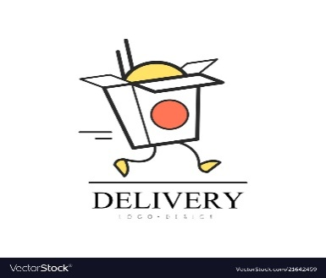

|  |
| --- |
| **THE PROJECT**  In bullet points, describe the problem this project aims to solve or the opportunity it aims to develop. |
| `Food delivery system is a simplified food ordering process. there are more traffic in the ordering system so to make them more efficient develop them to ensure right food delivery within few hours where we can deliver anything with ease with in a hour using a high tech and bicycles delivery in a few minutes |
| **THE HISTORY**  In bullet points, describe the current situation. |
| * Around 125 years ago, while under British rule, India developed the dabbawala meal delivery system in busy metropolitan areas, such as Mumbai. In response to the increased number of workers in cities, this meal delivery system relied on delivery men called dabbawalas. * Today we have advanced technology to deliver food in the form of drones and humans with ease in delivering food within 30 minutes of cooking. * With much advance in technology they can be delivered from home to home with ease. |
| **LIMITATIONS**  List what could prevent the success of the project, such as the need for expensive equipment, bad weather, lack of special training, etc. |
| Sometimes the delivery men put themselves in danger. There are much conflicts between restaurant and the delivery providers, has more quality has been less. The food could not be delivered on time due to traffic and the some misunderstanding leads to some conflict |
| **APPROACH**  List what is needed to complete the project. |
| Python/C/C++: Hypertext Pre-processor is language which began for developing web applications, is also a general-purpose programming language  MySQL: It is an open source relational database management system (RDBMS). MySQL is the central component of the WAMP open-source web application software stack. WAMP is an acronym for "Windows, Apache, MySQL and Perl/PHP/Python"  Hardware requirements:  V. HARDWARE REQUIREMENTS A desktop computer with Intel Core i3 64 bit processor and Graphic card 1 GB RAM, and Microsoft Windows 10 operating system was used. |
| **BENEFITS**  In bullet points, list the benefits that this project will bring to the organization. |
| * Makes the ordering process easier. * Efficient customer and order management. * Monitor your expenses incurred in real-time. * Better customers data * The convenience of mobile ordering. * Stay ahead of the competition. * Grow your bottom line.   Greater reach. |

Chapter 2

**Project Title: Food delivery system**

**Selection of Methodology**

Agile modeling (AM) is a methodology for modeling and documenting software systems based on best practices. It is a collection of values and principles, that can be applied on an (agile) software development project. This methodology is more flexible than traditional modeling methods, making it a better fit in a fast changing environment.It is part of the agile software development tool kit.

Usefulness in developing system in agile model is excellent in food delivery system

Documentation

Document continuously. Documentation is made throughout the life-cycle, in parallel to the creation of the rest of the solution.

Document late. Documentation is made as late as possible, avoiding speculative ideas that are likely to change in favor of stable information.

Executable specifications. Requirements are specified in the form of executable "customer tests", instead of non-executable "static" documentation.

Extreme Programming (XP) is a methodology that emphasizes teamwork, communication, and feedback. It focuses on constant development and customer satisfaction. Similar to scrum, this method also uses sprints or short development cycles. This is developed by a team to create a productive and highly efficient environment.

The extreme Programming technique is very supportive in a situation of constant and varying demands from the customers. It motivates the developers to accept changes in the customer’s demands, even if they pop up in an advanced phase of the development process.

In Extreme Programming, the project is tested from the initial stages by collecting feedback that progresses the output of the system. This also presents a spot check to easily implement any customer requirements.

### Modeling

Active stakeholder participation. Stakeholders of the solution/software being modeled should be actively involved with doing so. This is an extension of the on-site customer practice from Extreme Programming.

Inclusive tools. Prefer modelling tools, such as whiteboards and paper, that are easy to work with

Incorporate *Identification of Project Methodology and Stakeholder Description template*

| Stakeholder Name | Activity/ Area /Phase | Interest | Influence | Priority (High/ Medium/ Low) |
| --- | --- | --- | --- | --- |
| restaurant owners | mobile app and web app development | High | high | 2 |
| Customers | subscription using mobile apps | High | low | 1 |
| delivery partners | middle man delivery partners mobile app | High | high | 3 |

INTEREST AND INFLUENCE MATRIX

| Interest | Influence |
| --- | --- |
| High | High |
| High | Low |
| High | High |

| Stakeholders | Interests | Estimated project impact | Estimated priority |
| --- | --- | --- | --- |
| OWNERS | Achieve targets , increase sales | HIGH | 1 |
| MANGERS | efficient use of resources and serving | HIGH | 4 |
| CONSUMERS | attract towards online delivery system | High | 2 |
| SUPPLIERS | ensure feasible and  diverse areas. | medium | 5 |

.

Chapter 3

**Project Title: online food delivery system**

**System Requirements**

User RequirementsThe online ordering system must be quick and easy to navigate in addition to providinguseful features for browsing, selecting and purchasing products.

Required user interfacefeatures:

Navigation

Create customer account

Manage customer account

Browse items/product details

Add items to cart

Manage items in cart

**System Requirements :**

The online ordering system will require new software provided by an third party vendorthat will be able to handle the user requirements

. The system isexpected to be able to integrate with the existing ERP software in order to manage and updateinventory both in store and at warehouse locations based on customer orders. The system mustalso be able to coordinate customer order fulfillment with delivery times and methods. Updatesto customer account information must also be added and stored securely in the database. A newserver will be required to handle additional traffic and storage of customer information with thenew online order system.

**Functional Requirements**

1. Registration If customer wants to order the food then he/she must be registered, unregistered user can't go for ordering.

2. Login The customer bgin to the system by entering valid user id and password for ordering.

3. Display the menu In the system all the items are displayed with their rates.

4. Modify menu System can make changings in menu like adding or removing food items which are not available.

5. Select food items Items are selected customer feel free to order.

6. Changes to order Changes to order means the customer can make changings in order like he/she can delete or add food item in order.

7. Review the order before submitting Before submitting the complete order is reviewed to the customer. Customer name, phone number, location (address) and placed order, hen finally order is submitted.

8. Payment For customer there are many type of secure billing will be prepaid as debit or credit card, postpaid as after delivering, check or bank draft.

9. Provide delivery and payment details Here bill is generated, order no. and payment is given and confirmation of delivery is done.

10. Logout After the payment or surf the product the customer will log out.

**Non-Functional Requirements**

1. Portability System running on one platform can easily be converted to run on another platform.

2. Reliability The ability of the system to behave consistently in a user-acceptable manner when operating within the environment for which the system was intended.

3. Availability The system should be available at all times, meaning the user can access it using a web browser, only restricted by the down time of the server on which the system runs.

4. Maintainability A commercial database is used for maintaining the database and the application server takes care of the site.

5. Security Secure access of confidential data (customer information).

6. User friendly System should be easily used by the customer.

7. Performance Performance should be fast.

8. Efficient System should be efficient that it won't get hang if heavy traffic of order is placed.

9. Safety Data in the database of system should not loss or damage.

10. Privacy Personal data of the system should not disclose to anyone.

Chapter 4

# Project Management Plan

| **Focus Area** | **Details** |
| --- | --- |
| Schedule Management | Define Milestones  Schedule Control |
| Resource Management | Estimate and Manage the need  People: People & Skills Required  Finance: Budget Required  Physical: Facilities, IT Infrastructure |
| Risk Management | Identifying, analysing, and prioritizing project risks |

# Estimation

# Effort and Cost Estimation

| **Activity Description** | **Sub-Task** | **Sub-Task Description** | **Effort (in hours)** | **Cost in INR** |
| --- | --- | --- | --- | --- |
| Design the user screen | E1R1A1T1 (Effort-Requirement-Activity-Task) | Confirm the user requirements (acceptance criteria) | 3 | 1500 |
| E1R1A1T2 | Making data analysis | 2 | 1000 |
| E1R1A1T3 | Taking the scope of it | 1 | 500 |
| Identify Data Source for displaying units of Energy Consumption | E1RA2T1 | Go through Interface contract (Application Data Exchange) documents | 5 | 2500 |
| E1RA2T2 | Document | 4 | 2000 |

| **Effort (hr)** | **Cost (INR)** |
| --- | --- |
| 1 | 500 |

# Infrastructure/Resource Cost [CapEx

| **Infrastructure Requirement** | **Qty** | **Cost per qty** | **Cost per item** |
| --- | --- | --- | --- |
| RAM | 2 | 2500 | 50000 |
| laptop/computer | 2 | 80000 | 160000 |
| hard disk | 10 | 5000 | 50000 |

# Maintenance and Support Cost [OpEx]

| **Category** | **Details** | **Qty** | **Cost per qty per annum** | **Cost per item** |
| --- | --- | --- | --- | --- |
| People | Network, System, Middleware and DB admin  Developer , Support Consultant  Server | 3 | 2,000,000 | 6,000,000 |
| website | server  Database  Middleware  Network | 1 | 10000 | 10,000 |
| Infrastructures | Server, Storage and Network | 10 | 2000 | 20,000 |

# Project Team Formation

# Identification Team members

| **Name** | **Role** | **Responsibilities** |
| --- | --- | --- |
| SARAN | Key Business User (Product Owner) | Provide clear business and user requirements |
| RAAGUL | Project Manager | Manage the project |
| MADAR | Business Analyst | Discuss and Document Requirements |
| Mersel | Technical Lead | Design the end-to-end architecture |
| Raju | UX Designer | Design the user experience |
| VISHWA | Frontend Developer | Develop user interface |
| Sundar | Backend Developer | Design, Develop and Unit Test Services/API/DB |
| Lamdar | Cloud Architect | Design the cost effective, highly available and scalable architecture |
| Kanag | Cloud Operations | Provision required Services |
| Kingster | Tester | Define Test Cases and Perform Testing |

# Responsibility Assignment Matrix

| **RACI Matrix** | **Team Members** | | | |
| --- | --- | --- | --- | --- |
| **Activity** | **MADAR(BA)** | **VISHWA(Developer)** | **RAAGUL (Project Manager)** | **SARAN( Business User** |
| User Requirement Documentation | A | C/I | I | R |
| registration login | I | C/I | A | R |
| Client requirements | A | R | I | R |
| WEBSITE | C | R | A | I |
| PAYMENT | A | R | C | I |

| A | Accountable |
| --- | --- |
| R | Responsible |
| C | Consult |
| I | Inform |

Chapter 5

**WBS**

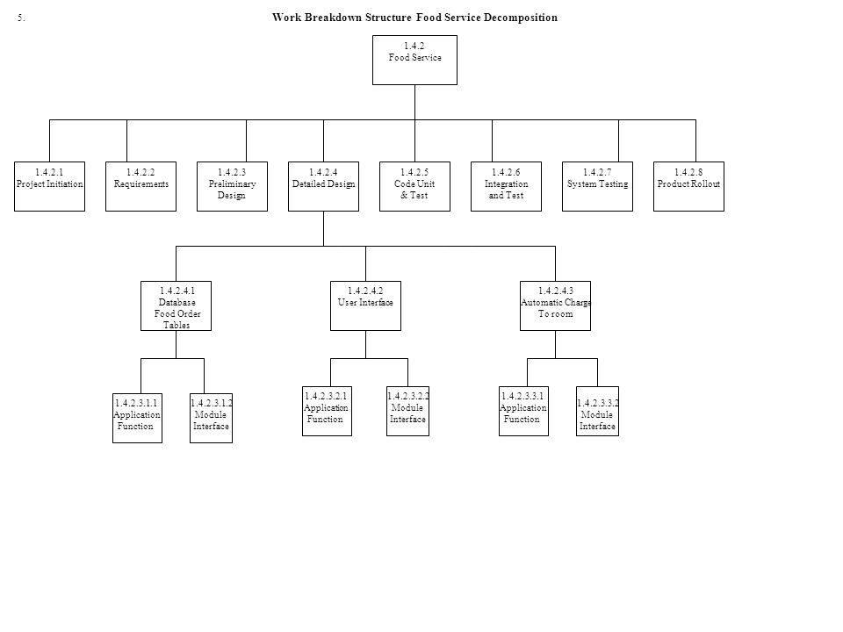

1.4.2 Food service

* 0.0 Project initiation
* 1.0 Project Requirements
* 2.0 primary design
* 3.0 code unit and test
* 4.0 detailed design
  + 4.1 Database food order test
    - 4.1.1 Application function
    - 4.1.2 Modular interface
  + 4.2 User interface
    - 4.2.1 Application Function
    - 4.2.2 Modular interface
  + 4.3 Automatic change to room
    - 4.3.1 Application Function
    - 4.3.2 Modular interface
* 5.0 Integration testing
* 6.0 system testing
* 7.0 product reliance

**TIMELINE – GANTT CHART**

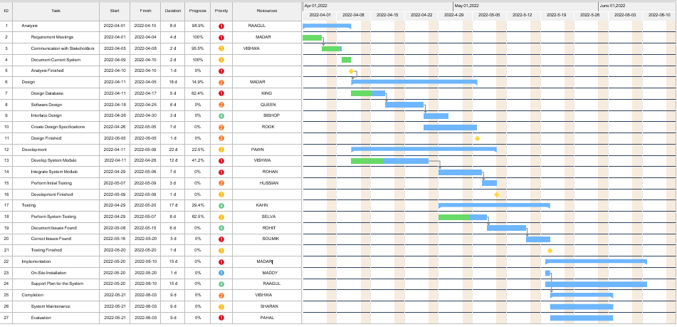

**RISK ANALYSIS – SWOT & RMMM**

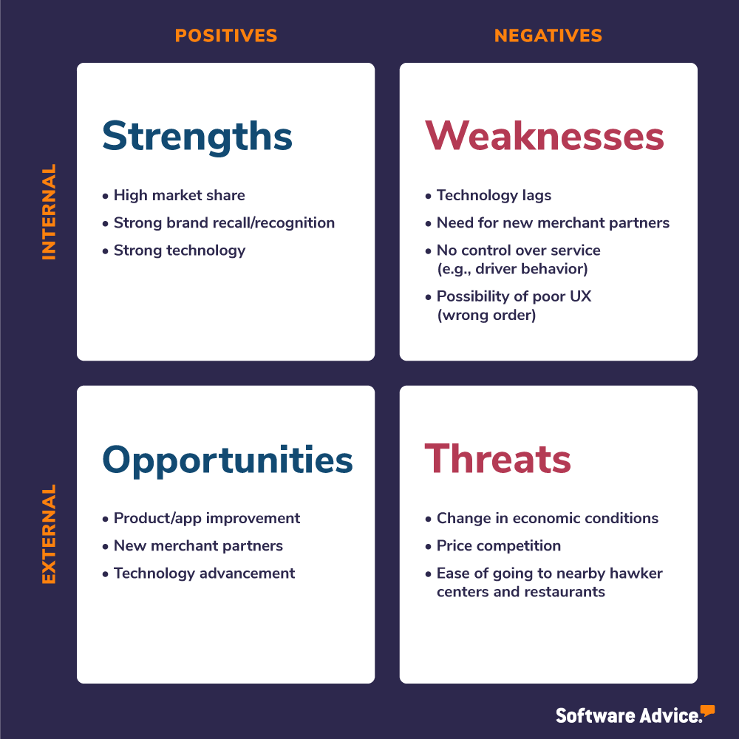

## Customer Privacy & Data

Back in the not-so-olden days, customers simply called up your restaurant to order. Their order was then delivered by a driver employed by the restaurant. Maybe they provided a credit card over the phone. Maybe they paid in cash at the door.  But times have changed. Now customers order on their cellphones and through food delivery apps like Uber Eats and Door Dash. **Sensitive data**, including credit card numbers, **is transmitted and frequently stored**, often across multiple networks and systems.

2. Food Safety Having the right equipment is a must for food safety & delivery.

Food safety should be a concern for every restaurant, whether they deliver or not. But it becomes especially important for delivery because of the additional risks. First and foremost, restaurants should be concerned about maintaining the correct hot and cold holding temperature. proper care of food products

Tampering

As delivery has exploded, there have been many innovations into what is called “tamper evident packaging.” This doesn’t mean “tamper proof.” The idea isn’t to make delivery containers into little puzzle boxes or portable safes. It is just another layer of protection for the business and the customer. Take out bags can be sealed with an adhesive that will tear the bag if removed. Carryout containers can have plastic seals that have to be broken to remove the food and cannot be replaced or resealed once broken.avoided by gaining some assurance to food .

Food quality

Food quality may be one of the most challenging problems for the industry to solve. There are so many factors to consider, many of which are beyond the control of the restaurant operator. proper maintenance of resources done.

## Delivery Driver Issues

This section could be an entire article by itself. But we will try to break it down for you. The last mile of your delivery service is in the hands of the person who drives the food to your customer. And a lot can happenbetween your restaurant and the customer’s location.

proper management should be done in a way that would avoid these.

Chapter 6

**SYSTEM ARCHITECTURE:**

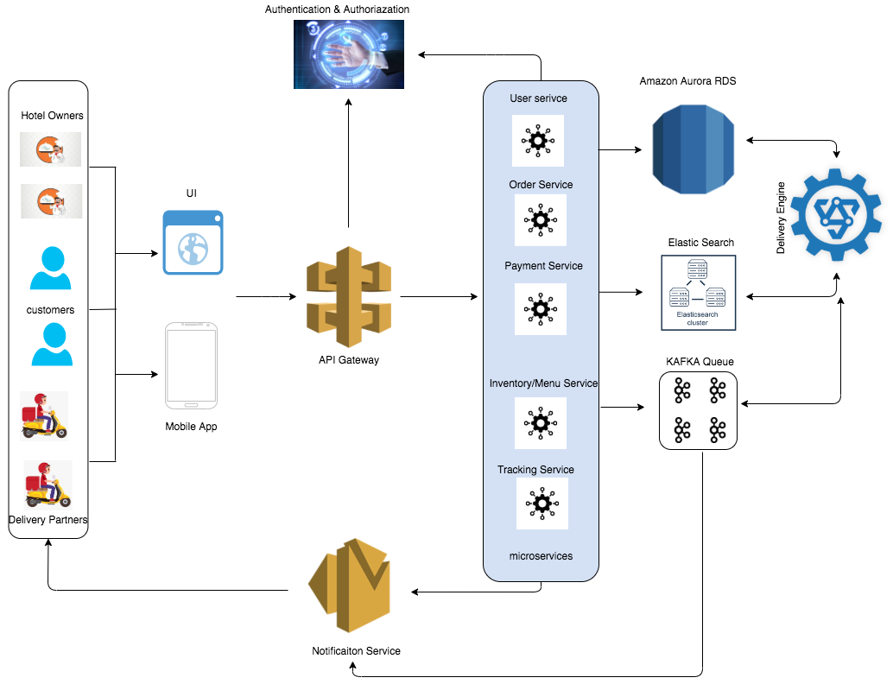

**USE CASE DIAGRAM:**

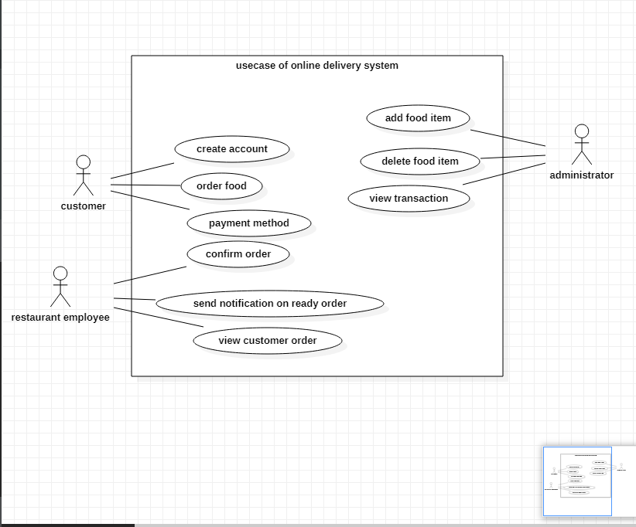

**CLASS DIAGRAM:**

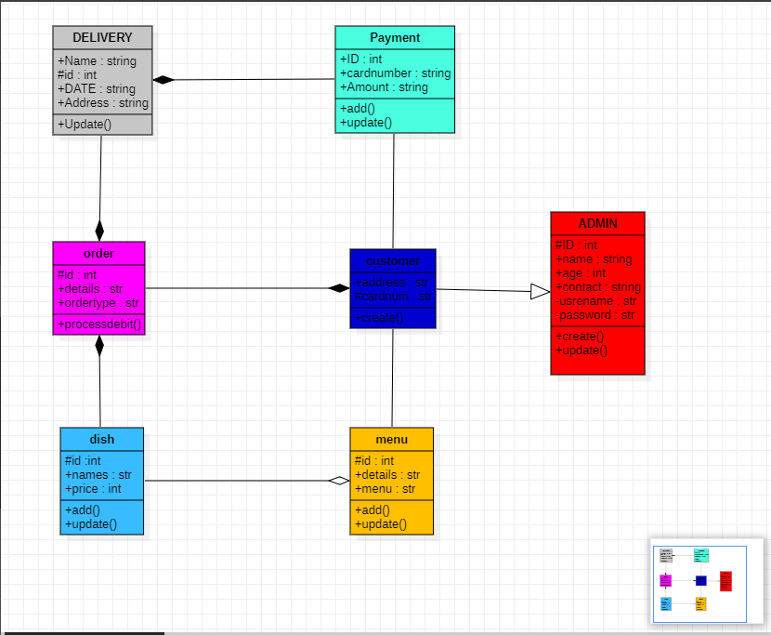

Chapter 7

**ER Diagram of food delivery system Database**

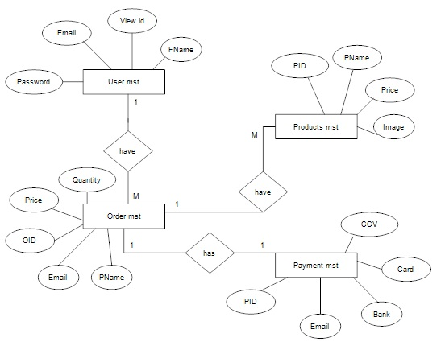

PAYMENT

ORDER

PRODUCTS

USER

Chapter 8

**DFD Level 0**

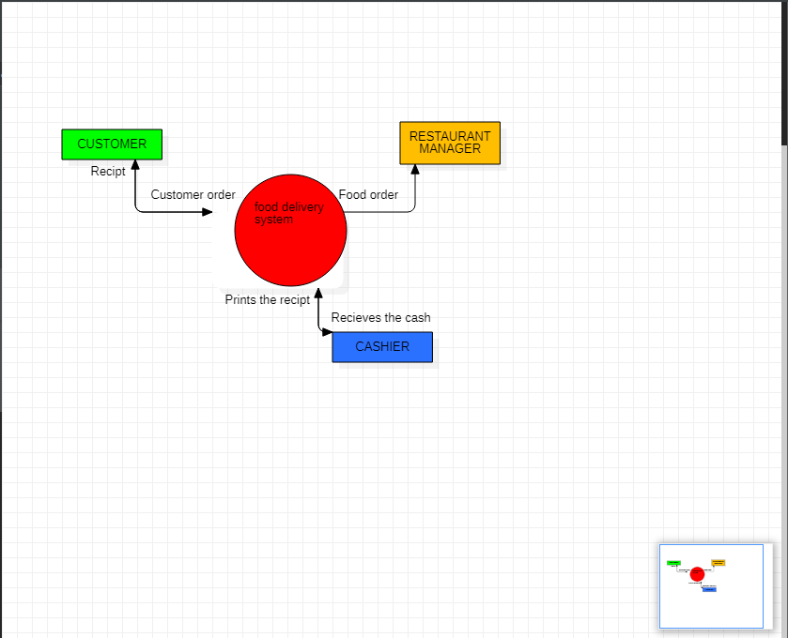

**DFD Level 1**

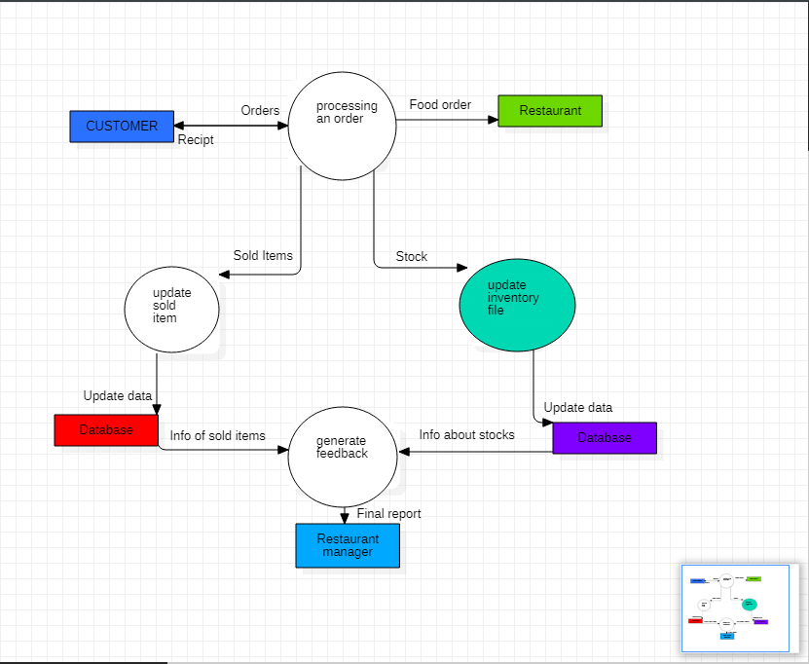

Chapter 9

**Sequence diagram:**

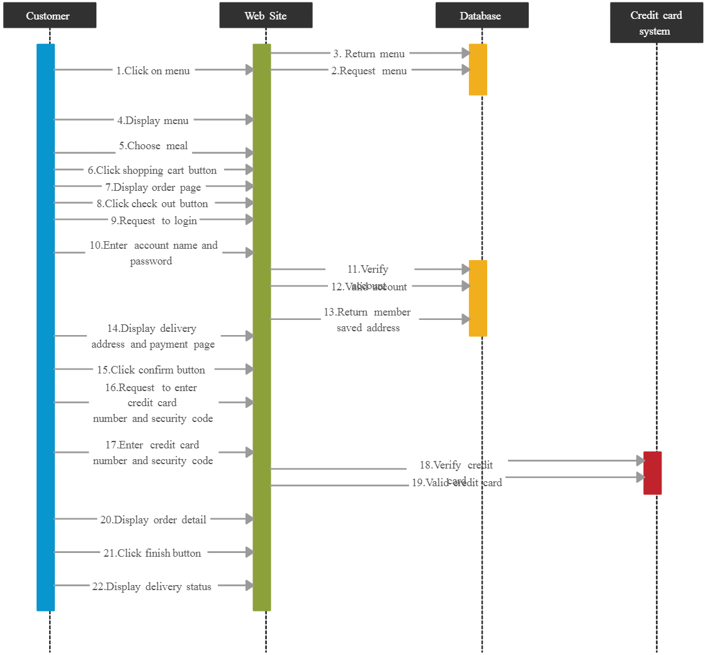

**Collabaration diagram:**

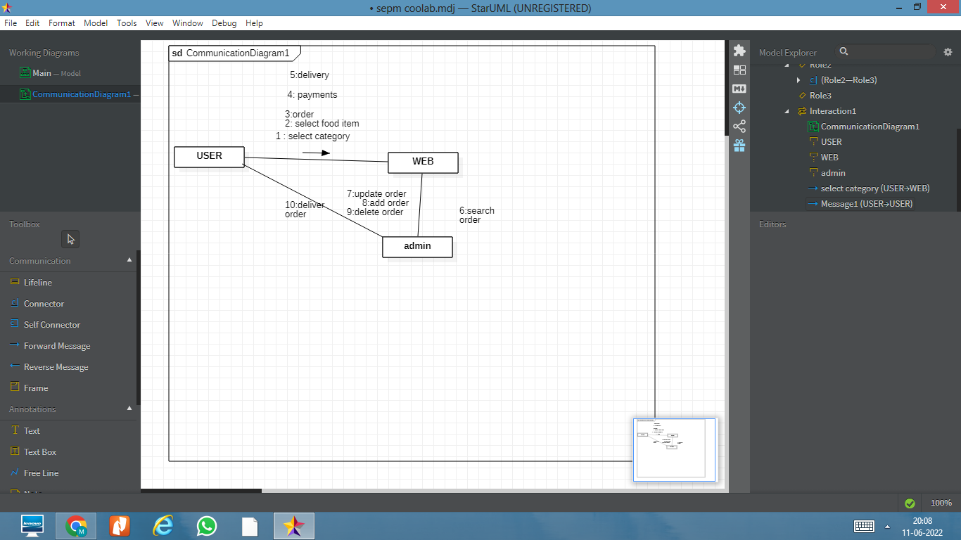

Chapter 10

# Executive Summary

Testing Framework:

* accuracy
* efficiency

# Test Plan

ACCURACY: does the software can deliver the accurate address and order placement

Efficiency:does is efficient to handle 24/7 for food delivery system, workstructure.

# Scope of Testing

ACCURACY:ensure that it has the accurate among the order placed

Efficiency:that the performance can be enhanced by it, and its information

**Functional:**

| test area | Input | testing method | Tools |
| --- | --- | --- | --- |
| login module | login/username and password | manual | security infrastructure |
| menu selection | - | automated tools | web application |
| payment | details of your bank account | manual | web application |

**Non-Functional:**

| test area | testing method | Tools |
| --- | --- | --- |
| Security | automated tools | Zap |
| performance | automated or manual | web load |
| Accessibility | automated tools | Achecker |

# Types of Testing, Methodology, Tools

| Category | Methodology | Tools Required |
| --- | --- | --- |
| Functional Requirements | Manual | Word Template |
| Security | agile security testing | Zap |

Chapter 11

# Functional Test Cases

| **Test ID (#)** | **Test Scenario** | **Test Case** | **Execution Steps** | **Expected Outcome** | **Actual Outcome** | **Status** | **Remarks** |
| --- | --- | --- | --- | --- | --- | --- | --- |
| 1 | Verify User Registration from India | Accept Valid India Mobile Number | 1. User clicks on User Registration link 2. Enter the mobile Number on the text box 3. Click Register button | the number should be 10 digit number  or below it would be not considered | the number should be having the 10 digit  else it would become other than indian number | Pass  Pass | success  success |
| 2 | Verify User Registration from India | Don’t Accept Non IndianMobile Number on | Payment | user senerio | indian number  foreign number | progress  fail | success  failure |

# 

# 

# Non-Functional Test Cases

| **Test ID**   | 1 | | --- |   **(#)** | **Test Scenario** | **Test Case** | **Execution Steps** | **Expected Outcome** | **Actual Outcome** | **Status** | **Remarks** |
| --- | --- | --- | --- | --- | --- | --- | --- | --- |
| 1 | Availability | Works 24/7 | Works for more time | Work process | Efficient in usuasge | process | Nil |
| 2 | Portable | Shipped | Correct usage | User senerio | Done well | sucess | nil |
| 3 | data security | secure | Check for security | Secure | Well executed | success | Better updated |
| 4 | data privacy | Efficient | Data secured | Secure | Well executed | success | good be better |

.

Chapter 12

**TEST CASES**

| **Category** | **Progress Against Plan** | **Status** |
| --- | --- | --- |
| Functional Testing | building up software,amber | In-Progress |
| Non-Functional Testing | availability ,portable,amber | not yet done |

| **Functional** | **Test Case Coverage (%)** | **Status** |
| --- | --- | --- |
| registration menu | 30% | In-Progress |
| choice of menu | 20% | in progress |
| payment details | 10% | not started |

Chapter 13

Implementation

This chapter provides an overview of the implementation process. In first, the

implementation of the frontend part is described. After that, different backend

functionalities have been discussed and evaluated.

The user interface of the application is responsive. So, the interface can occupy the

full screen in any kind of device. For making the user interface of the application

mobile friendly.

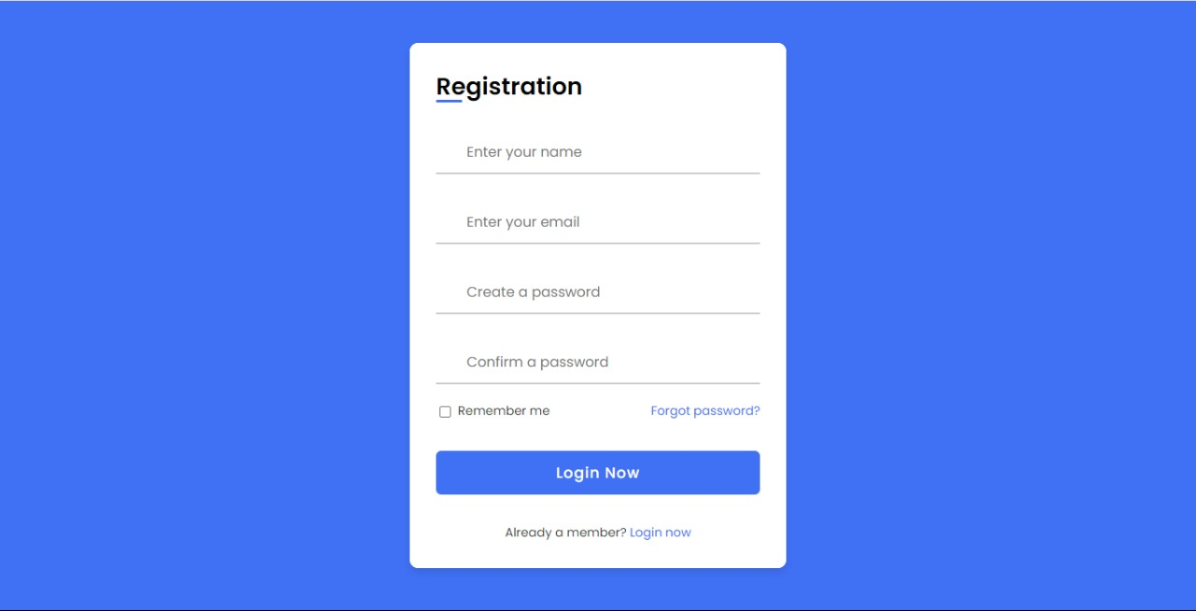

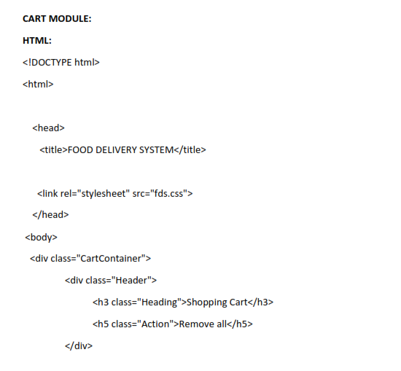

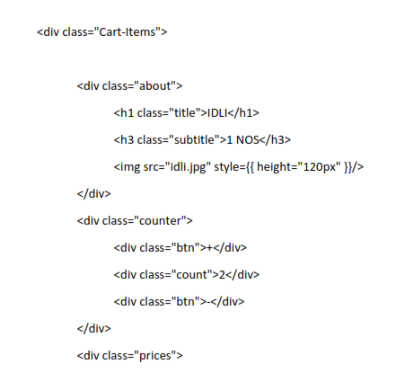

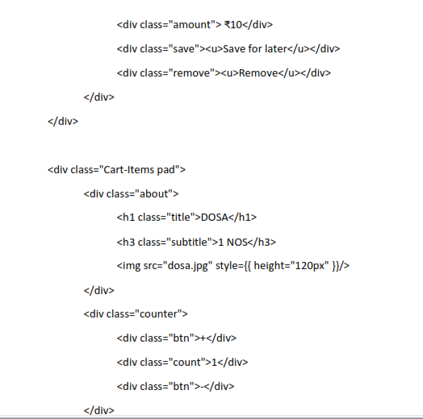

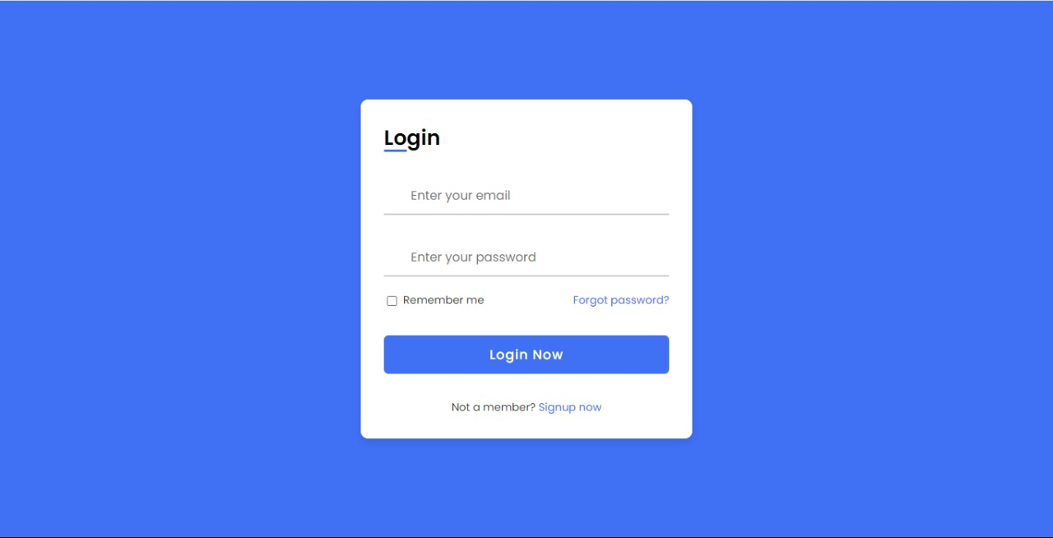

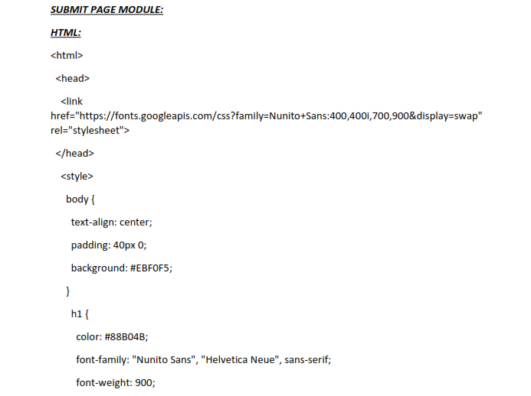

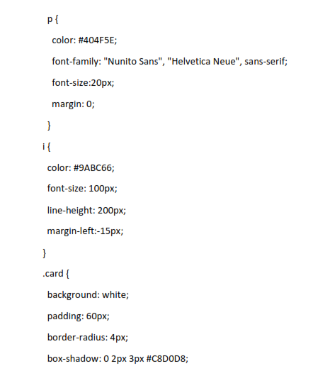

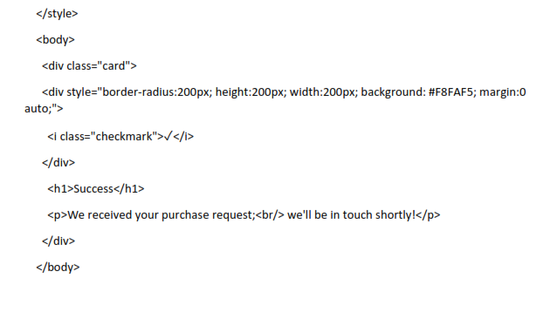

Another feature of our application is shopping cart. User can add products to cart andorder before checking out from the website. To make that, two controllers have beenmade to calculate the price of products and show subtotal and total. The cart shows allof the products user added to cart and their prices and quantity. User can add orsubtract product quantity or remove the products by clicking on buttons. Wheneverthe user add or subtract any product, he or she can see the subtotal and total of cost.Whenever a user tries to add product to the cart the authentication is checked againstauth middleware. So, a construct function is made in the Cart Controller.

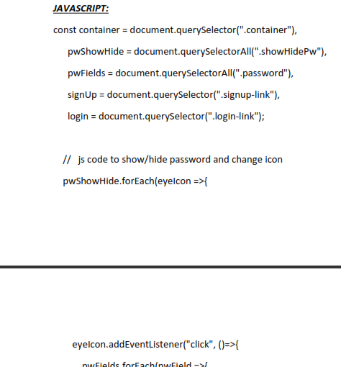

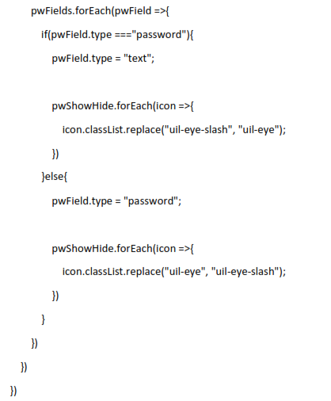



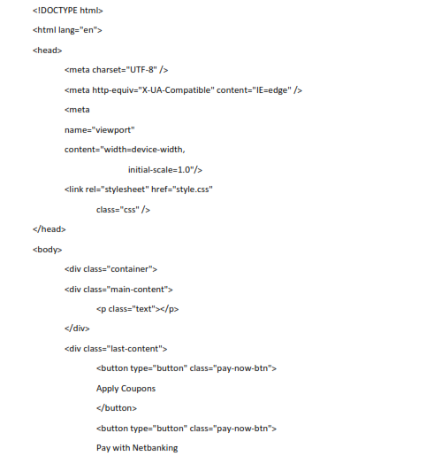

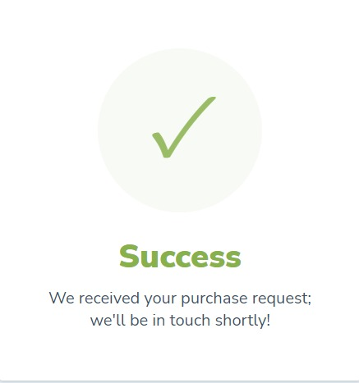

.

Conclusion

 An online food delivery system is proposed which is useful in small family run restaurants as well as in places like college cafeteria, etc. This project can later be expanded on a larger scale. An online food delivery system is developed where the customers can make an order for the food and avoid the hassles of waiting for the order to be taken by the waiter. Using the application, the end users register online, read the E-menu card and select the food from the e-menu card to order food online. Once the customer selects the required food item the chef will be able to see the results on the screen and start processing the food. This application nullifies the need of a waiter or reduces the workload of the waiter. The advantage is that in a crowded restaurant there will be chances that the waiters are overloaded with orders and they are unable to meet the requirements of the customer in a satisfactory manner. Therefore by using this application, the users can directly place the order for food to the chef online. In conclusion an online food ordering system is proposed which is useful in small family run restaurants as well.

REFERENCES

1. Awojide, Simon, I. M. Omogbhemhe, O. S. Awe, and T. S. Babatope, “Towards the digitalization of Restaurant Business Process for Food Ordering in Nigeria Private University: The Design Perspective. A Study of Samuel Adegboyega University Edo State Nigeria,” Int. J. Sci. Res. Publ., vol. 8, no. 5, pp. 46–54, 2018. 2. O. I. Mike and A. Simon, “Towards the Digitalization of Hotel Business in Nigeria: The Design Perspective,” vol. 8, no.

2, pp. 1175–1178, 2017.

3. Adithya. R., A. Singh, S. Pathan, and V. Kanade, “Online Food Ordering System,” Int. J. Comput. Appl., vol. 180, no. 6, pp. 22–24, 2017.

4. Varsha Chavan, Priya Jadhav, Snehal Korade, Priyanka Teli, ”Implementing Customizable Online Food Ordering System Using Web Based Application”, International Journal of Innovative Science, Engineering Technology(IJISET) 2015.

5. Patel, Mayurkumar, "Online Food Order System for Restaurants" (2015). Technical Library. Paper 219. 6. php code [online] available at www.w3schools.com 7. mysql code [online] available at www.stackoverflow.com